The Log Book

Mateusz Larkowski
Computer Science
u1864886

Part 1.
Modelling
- Introduction
- Scenario Analysis
- Modelling with Activity Diagrams
- Use Case Diagrams
- Introduction to Objects and Classes
- Relationships
- Sequence Diagrams
- Case Study – Odd Shoe Company
- Design Objects
- Intro to Databases

1.Introduction

The Unified Modelling Language (UML) is a notation for recording models of computer systems. It is the most commonly used modelling language nowadays and the methods described later are applicable to the development of large, complex computer software systems. In fact, the more complicated the system under development, the more important it is that we follow all of the stages of development carefully and completely.

UML is not a way of providing models for a project manager. It is really a notation for analysts and developers. There is more to modelling in a project than UML.
Please note that notation is not the same as method.
We model because it is easier and cheaper to build a model than the real thing, or, for example, because the real thing is difficult to carry.

When you construct a model, you come across problems that are easier to solve at the modelling stage than at the construction stage.

Models are useful for communication. A complex construction will require lots of groups to work together. If they work from models that fit together, then the things they produce should fit together.

At another level, models are used to describe things that you might want to buy - a travel brochure is a simple model of a holiday resort.

TutPrac01

Question 1.

1. List 5 reasons (from notes or from your own ideas) why we model.

We model because it is easier and cheaper to build a model than the real thing.
We model to spot potential weaknesses and problems the project might have/face.
We model to open communication lines with other team members.
We model to stay organized.
We model to come up with better solution than if we started without modeling.

2. Explain briefly why we sometimes do not need to model.

We do not need to model if modelling would take more time than actual programming, or more generally, if the project takes up to two days. Modelling in that case is just waste of time and resources.

3. List (from the notes or from your own ideas) at least 5 kinds of models used in business
- Business Case
- Business Requirements
- Use Case Diagrams
- Activity Diagrams
- Collaboration Diagrams

4. Define what is meant by The UML

The Unified Modelling Language

5. List at least 5 notations included in the UML
- Use Case Diagrams
- Activity Diagrams
- Sequence Diagram
- Collaboration Diagrams
- Class Diagrams
- Component Diagrams
- Deployment Diagrams

Question 2.
For each of the following types of model, explain:
- What is being modelled
- How it is being modelled
- What is being left out of the thing being modelled.
Model case : Architect’s plan for a building
In this case, being modelled is a building itself. Elevations, every room on every floor. Every single m3. All windows, stairways, fire exits. The pipelines as well as the electricity supply lines.

To escape, you must bribe the guard from a stock of money you have secretly buried in the dungeon, climb the stairs to the first floor, capture a guest at the banquet, steal their clothes, sneak through the banquet, get out into the castle grounds, cross to the gate, get out of the gate, walk across the drawbridge, steal a horse and ride away into the sunset. Any time you are caught, you are returned to the dungeon. You win if you get away. You lose if you run out of money and end up back in the dungeon. Invent some interesting problems along the way and provide a primary and alternative path analysis of the game.

- Wake up in the dungeon.
- Dig up your gold stash.
- Take half.
- Bury back in.
- Call the guard.
- Bribe the guard for half of your gold.
- Give the guard other half for his baton.
- Climb the stairs to the first floor.
- Wait by the door, until single person walk’s past.
- Knock him down using your baton.
- Move unconscious body back onto the stairs.
- Steal their clothes.
- Sheath your weapon so it is not visible.
- Check pockets for gold and valuables.
- Go to the banquet.
- Be confident. If you see a free drink, grab it.
- Sneak your way out the front door.
- Get out into the castle grounds.
- You can walk faster now, don’t run though.
- Cross the gate.
- Get out of the gate.
- Walk across the drawbridge.
- Find a horse.
- If you have enough money, buy the horse. Otherwise, hide and wait for the right moment to steal it.
- Ride away into the sunset.

2.1 Gold stash half empty
- Take it all.
- Bribe guard with all gold.

  - Guard doesn’t accept.
- Give him all the gold instead and skip to 8.
7.1 Guard doesn’t accept.
- Skip to 8.
7.2 Guard doesn’t accept & takes the money.
- Don’t pick up a fight. Enjoy your temporary freedom.
8.1 Different guard walking down the stairs.
- Fight the guard with your baton.
- Else, if you don’t have the baton, loose other guard on the stairway

TutPrac02

Scenario “Getting money out of a cash machine”

Primary

1. Put your bank card in the cash machine
2. Type in your PIN
3. Choose “cash withdrawal without the recipe”
4. Choose how much you want to take out.
5. Wait for the cash machine to process your transaction.
6. take your card
7. and wait for your money

5.1 PIN number wrong
- Print message on screen
- Ask user to retype PIN number
5.2 PIN number typed wrong for 3rd time
- Print message
- Block the card
5.3 Insufficient funds on the card
- Print message
- Ask if user wants another transaction or abandon
6.1 Card not given back
- Contact cash machine operator
7.1 Money charged but not given
- Contact your bank branch
- Provide details of cash machine operator and location

Scenario “Baking a cake”

Primary

1. Look up the recipe
2. Gather all the ingredients
3. Preheat the oven
4. Put all of the ingredients into a mixing bowl
5. Mix all the ingredients together.
6. Grease the baking tray
7. Put your cake mix into the baking tray
8. Put your baking tray into the oven
9. Wait 40 min
10. Check with a stick if your cake is ready (if the cake is done, stick shouldnt be wet after stabbing the cake)
11. Glaze your cake with chocolate
12. Wait until the cake cools off
13. Serve and enjoy

3.1 Oven not turning on
- Check power supply
- If not it, contact electrician/landlord
4.1 Mixing bowl got broken
- use another bowl/buy a new one
7.1 Ingredients do not fit in the baking tray
- get bigger baking tray
10.1 Cake not ready yet
- Wait extra 10 min

Scenario “Ordering a book from a web-based book store (e.g. Amazon)”

Primary

1. Log into online store
2. Find the book you are interested in
3. Add the book to your basket
4. Proceed to checkout
5. Fill in your delivery address
6. Type in promo code if owned
7. Choose payment method
8. Type in your billing address if different than delivery
8. Check your details
9. Store processes your details and checks with your bank
10. Order placed. Continue shopping or end.

  - Log in error
- Ask user to check username and password
3.1 Book not found in cataloque
- Ask user to find product again
- If still not working, contact customer service department
7.1 Promo Code unknown
- ask to use different code
9.1 Bank details incorrect
- ask user to correct details
9.2 Insufficient funds
- ask to choose different payment method

TutPrac03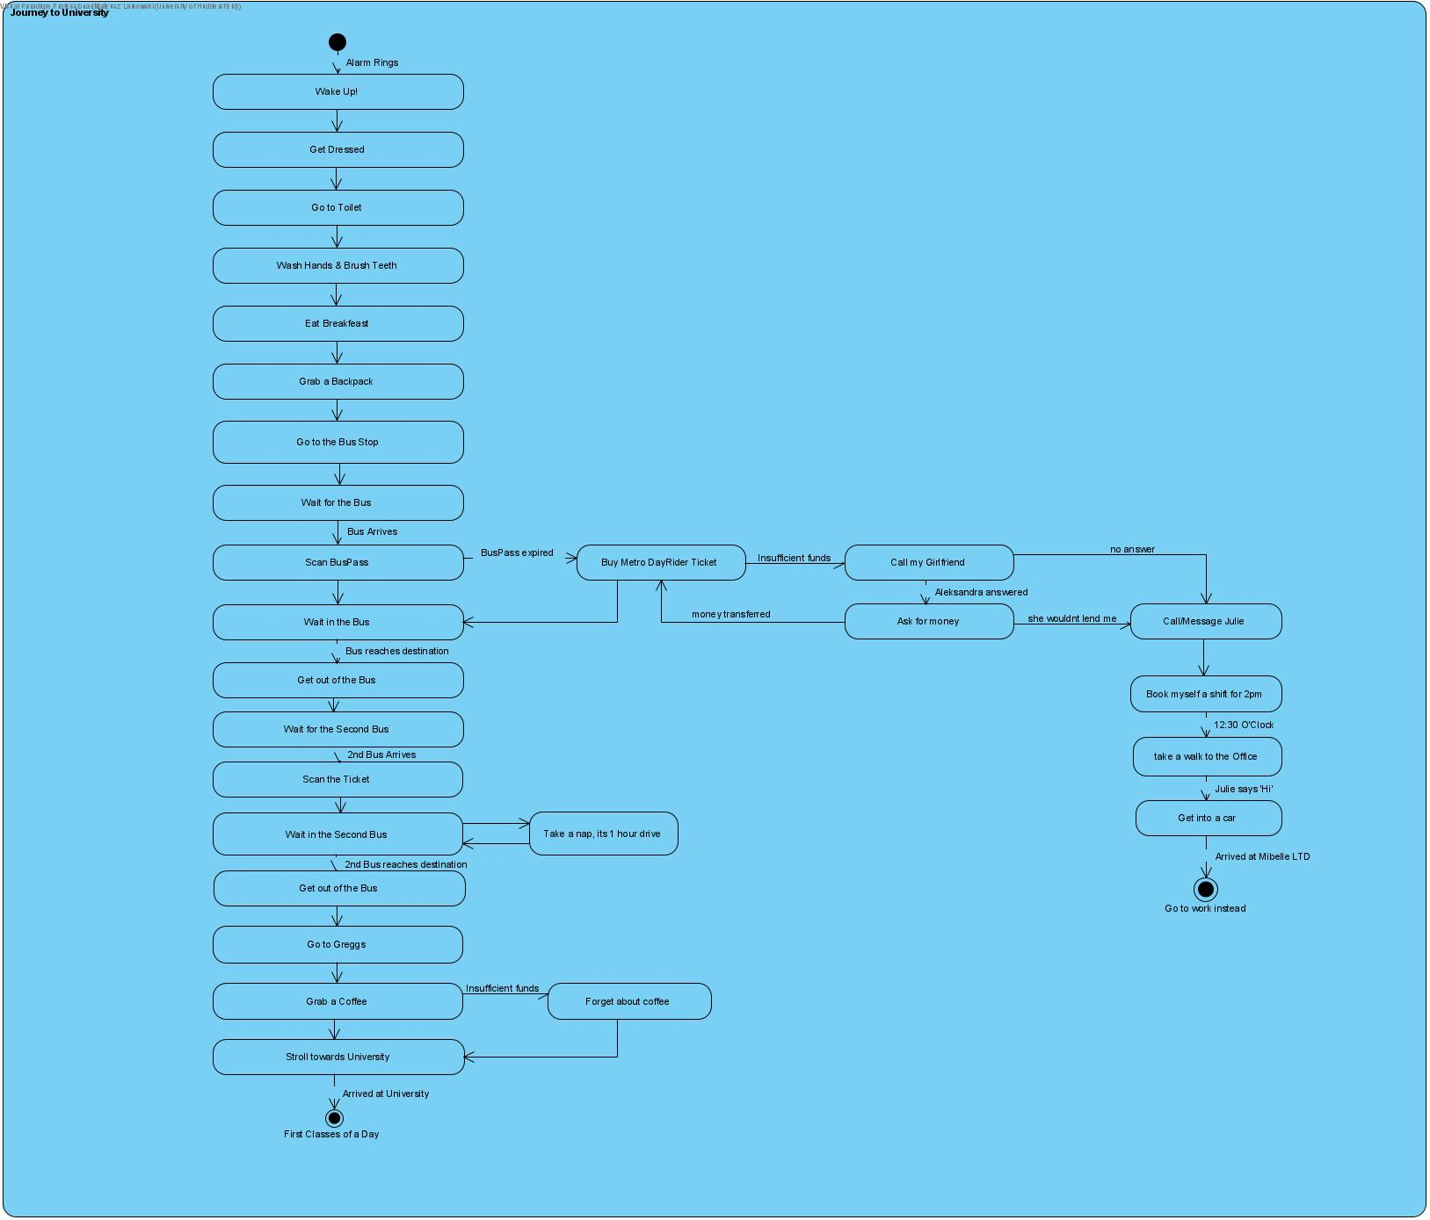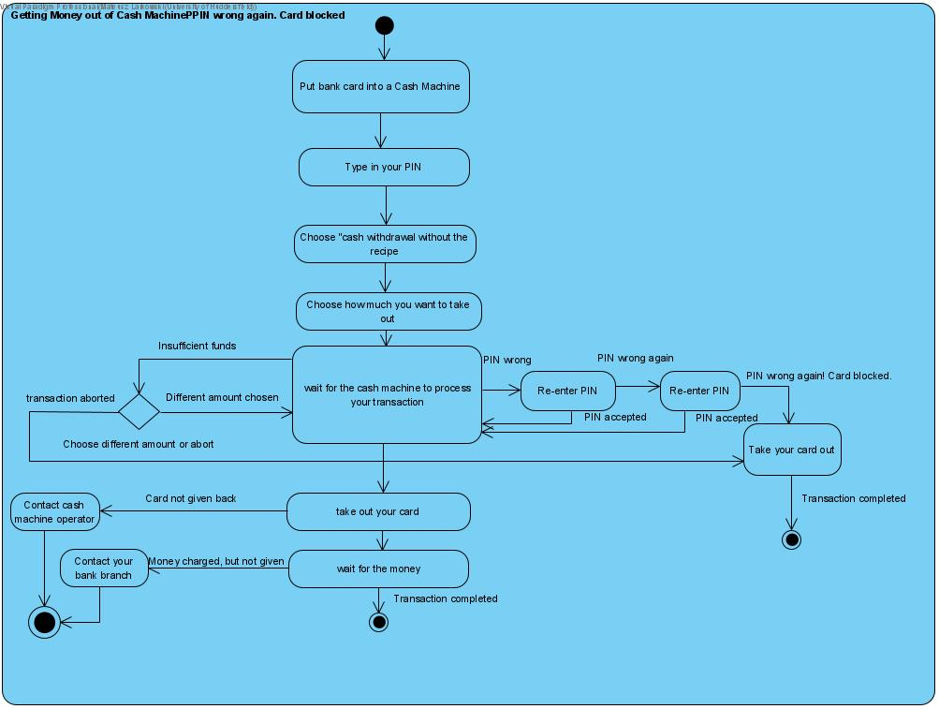
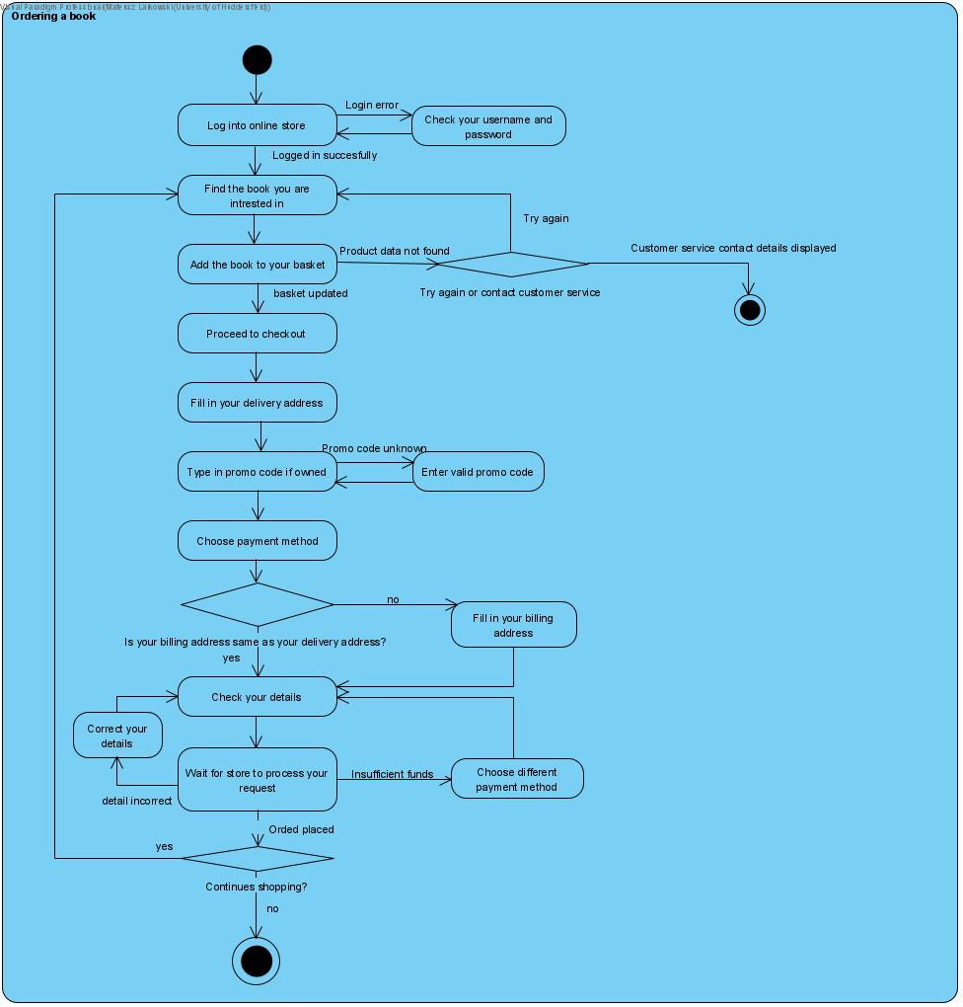

TutPrac04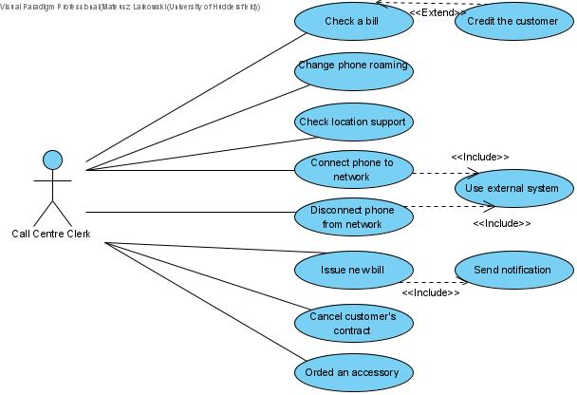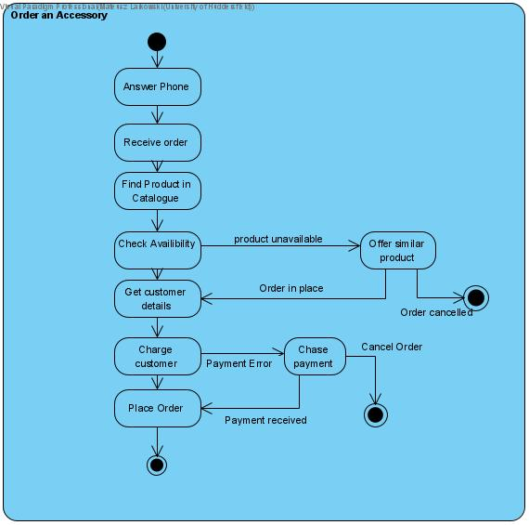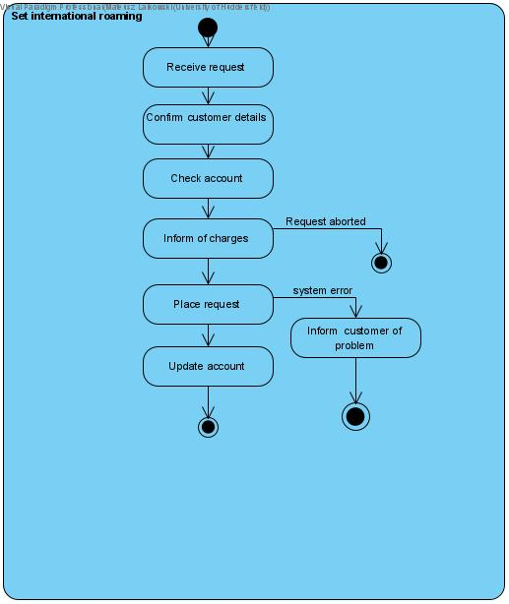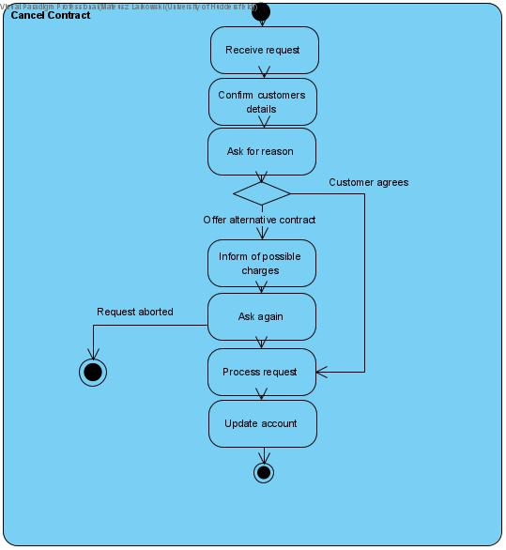

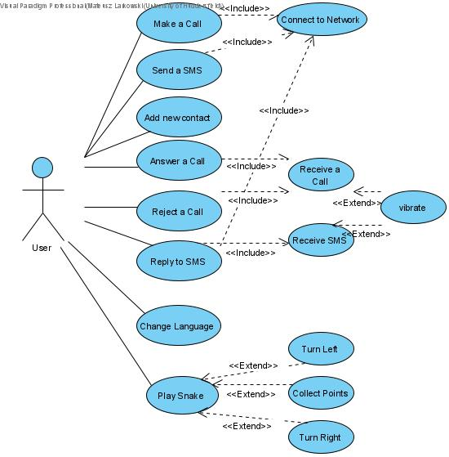

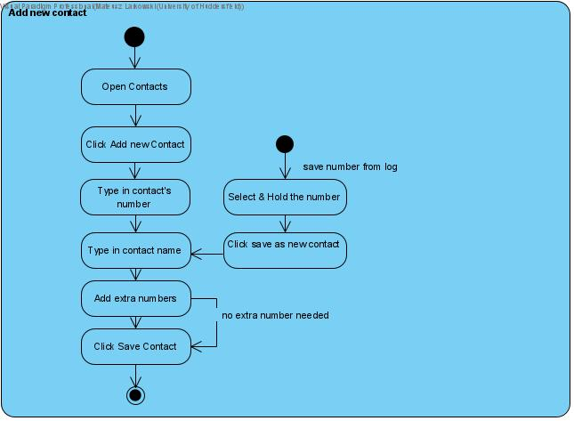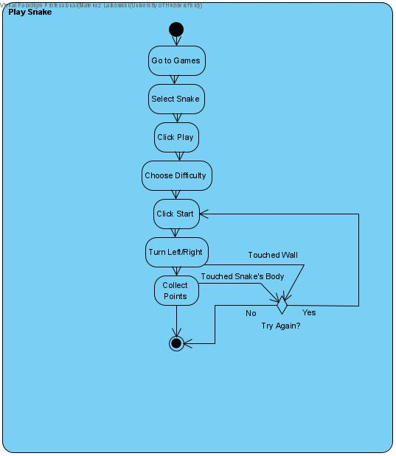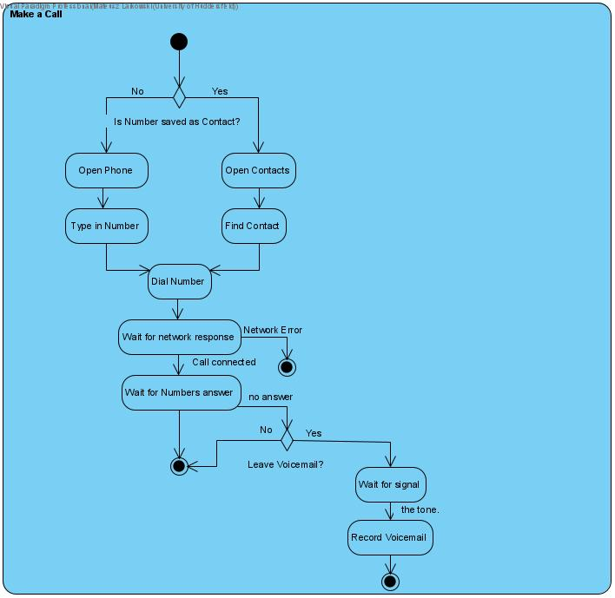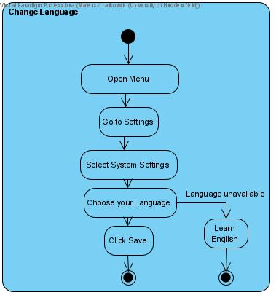

Use Case Number: | Use Case Name:
Brief Description:
Actors:
Pre-conditions:
Post-conditions:
Frequency of Execution:
Scalability:
Criticality:
Primary Path:
1.
Use Cases Related to Primary Path:
Alternatives:
Use Cases Related to Alternatives:
Exceptions:
Use Cases Related to Exceptions:
Data Requirements:
User Interfaces:
Change Record:

Use Case Number: | Use Case Name:
Brief Description:
Actors:
Pre-conditions:
Post-conditions:
Frequency of Execution:
Scalability:
Criticality:
Primary Path:
1.
Use Cases Related to Primary Path:
Alternatives:
Use Cases Related to Alternatives:
Exceptions:
Use Cases Related to Exceptions:
Data Requirements:
User Interfaces:
Change Record:

Use Case Number: | Use Case Name:
Brief Description:
Actors:
Pre-conditions:
Post-conditions:
Frequency of Execution:
Scalability:
Criticality:
Primary Path:
1.
Use Cases Related to Primary Path:
Alternatives:
Use Cases Related to Alternatives:
Exceptions:
Use Cases Related to Exceptions:
Data Requirements:
User Interfaces:
Change Record:

Use Case Number: | Use Case Name:
Brief Description:
Actors:
Pre-conditions:
Post-conditions:
Frequency of Execution:
Scalability:
Criticality:
Primary Path:
1.
Use Cases Related to Primary Path:
Alternatives:
Use Cases Related to Alternatives:
Exceptions:
Use Cases Related to Exceptions:
Data Requirements:
User Interfaces:
Change Record:

Use Case Number: | Use Case Name:
Brief Description:
Actors:
Pre-conditions:
Post-conditions:
Frequency of Execution:
Scalability:
Criticality:
Primary Path:
1.
Use Cases Related to Primary Path:
Alternatives:
Use Cases Related to Alternatives:
Exceptions:
Use Cases Related to Exceptions:
Data Requirements:
User Interfaces:
Change Record:

Use Case Number: | Use Case Name:
Brief Description:
Actors:
Pre-conditions:
Post-conditions:
Frequency of Execution:
Scalability:
Criticality:
Primary Path:
1.
Use Cases Related to Primary Path:
Alternatives:
Use Cases Related to Alternatives:
Exceptions:
Use Cases Related to Exceptions:
Data Requirements:
User Interfaces:
Change Record:

Use Case Number: | Use Case Name:
Brief Description:
Actors:
Pre-conditions:
Post-conditions:
Frequency of Execution:
Scalability:
Criticality:
Primary Path:
1.
Use Cases Related to Primary Path:
Alternatives:
Use Cases Related to Alternatives:
Exceptions:
Use Cases Related to Exceptions:
Data Requirements:
User Interfaces:
Change Record:

TutPrac05
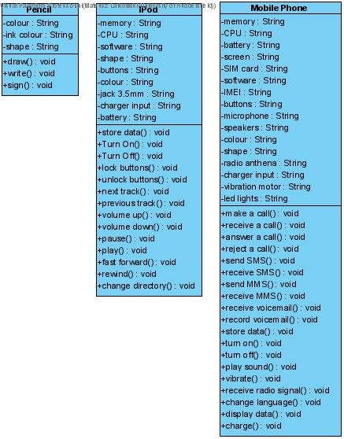

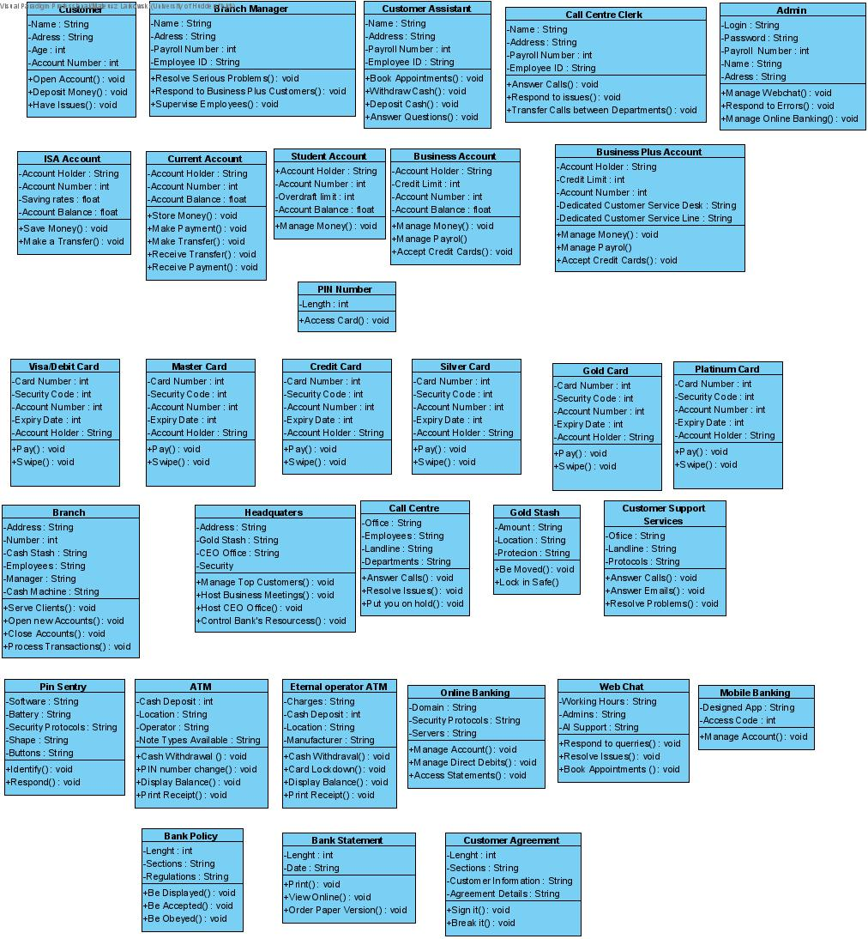

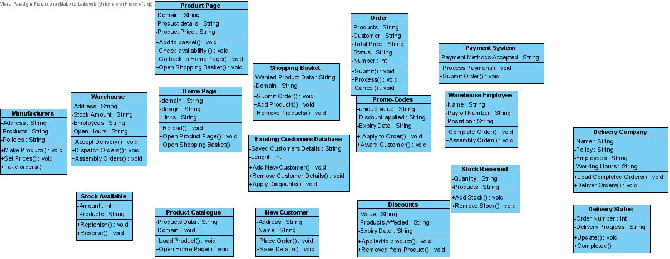

Part 2.
Programming

Practical week 1 27.09.18

7.12. ⇉ Change the program to output your name. (Note that you can now run it by clicking the small green arrow to the left of the "Run" window.) Take a screenshot of your first program (with the output showing below) for your logbook!
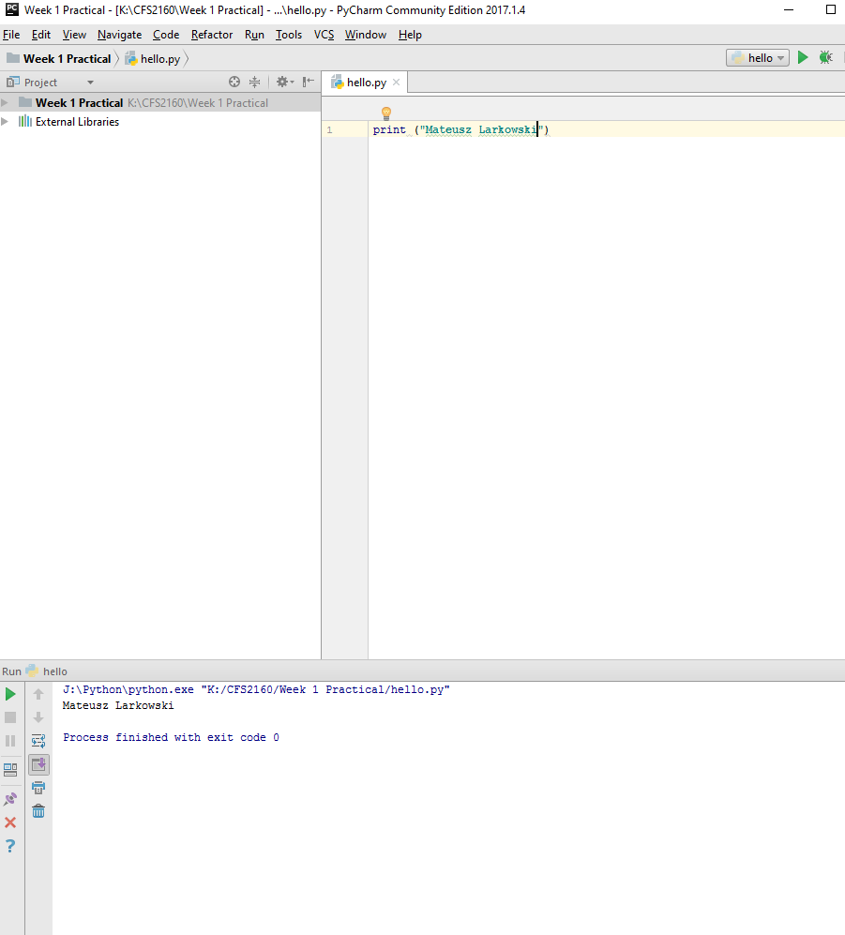

10. ⇉ Note down all the Git commands you use, and include them in your logbook along with a brief description of what they do.

git commit -m “commit name” → add files from local repository to commit
git push origin master → pushes commits to master branch (online on github)
git init → initialize an existing directory as a Git repository
git add→ updates the index of the directory (tells GitHub that files you added are there)
git remote add [alias] [url]→ add a git URL as an alias
git pull→ fetch and merge any commits from the tracking remote branch

git clone [url] → clone online repository to directory you are in (creates folder named
after your repository)
git remote -v → verifies the connection with github (should return fetch and push lines)

Practical week 2 4.10.2018

5. ⇉ A kindly teacher has a bag of sweets to be shared among a class of pupils. There are 35 sweets in the bag, and 15 pupils in the class. Write out expressions that will determine how many sweets each pupil will get, and how many sweets will be left over for the teacher. Test these at the Python console, and take a screenshot for your logbook.
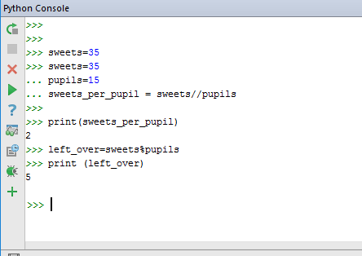

6. ⇉ Write a program that creates two variables like so (as the first two lines): number_of_pupils = 16 number_of_sweets = 47 and then prints out the number of sweets for each pupil, and the number of sweets left over. Include the program in your logbook (as a screenshot, showing the output).
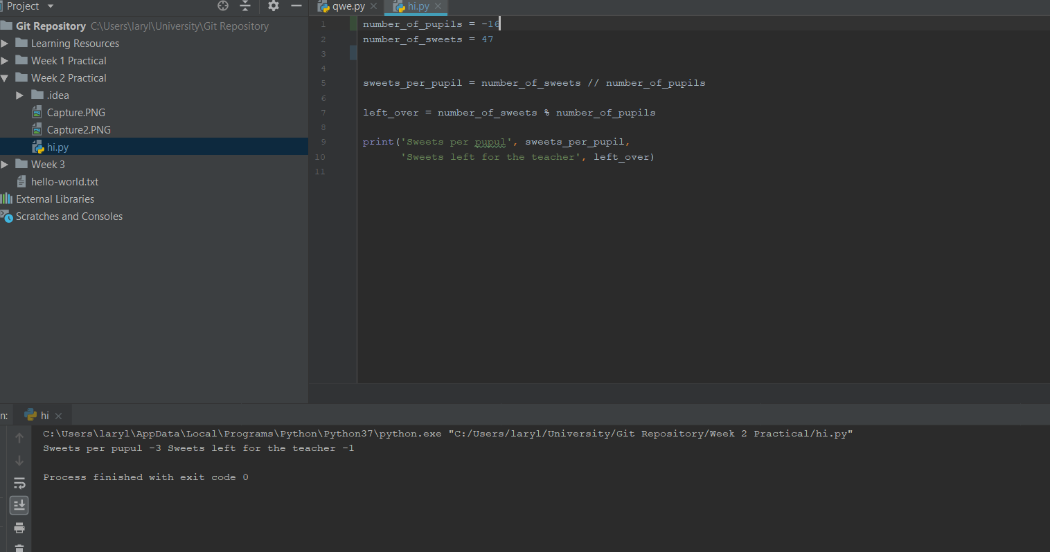

9. If you are feeling confident, go ahead and do some research and fix the problem of a negative value for the numbers of pupils and sweets. Handle zero for either too (the fix is probably different). At the same time, you could modify the program so that the user can enter the number of pupils and sweets at a suitable prompt or prompts.
10. If you manage the task above, investigate what happens if the user enters a floating-point value or string at your prompt that expects an integer. Can you work out how to fix this?

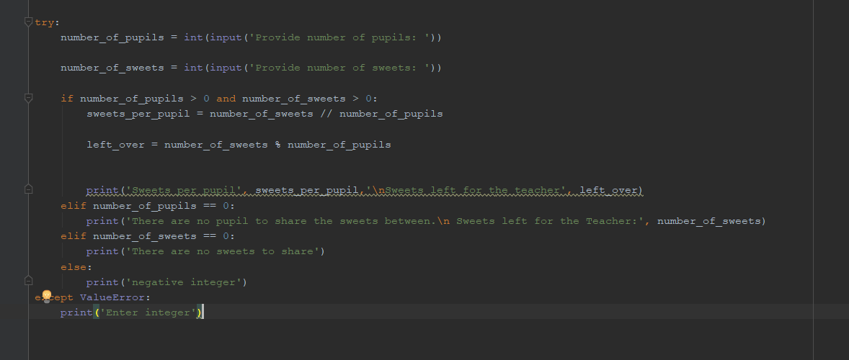

Practical Week 3 11.10.2018

2.⇉ Create a table of values (put it in your logbook) that could be used to test your program.
The left most column is the number of pupils, the next is the number of sweets; the remaining two should show the expected results from that number of pupils and sweets (i.e. the number of sweets each pupil will receive and the number of sweets left over). Add at least three rows to the table, and take screen shots of your program's results to show that it works. Include these, along with the program itself, in your logbook.

Number of pupils | Number of sweets | Sweets per student | Left over sweets
48 | 150 | 3 | 6
30 | 60 | 2 | 0
27 | 0 | 0 | 0
-2 | 40 | N.A. | N.A.
40 | 4.8 | N.A. | N.A.
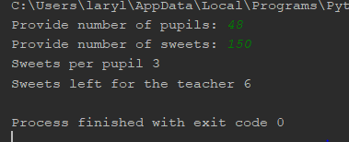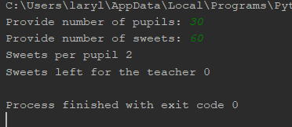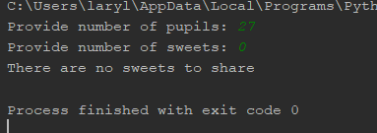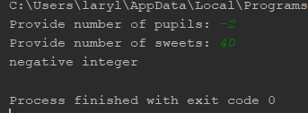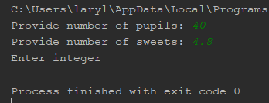

7.⇉ Your first program in the very first practical printed the message "HelloWorld" (or something similar). Take a copy, and amend It so that it prompts the user to enter their name, and then displays a personalised greeting. It might work something like this:
Hello, who are you? Arthur
Hello, Arthur. It is good to meet you.
Include a screenshot showing your program working in your logbook
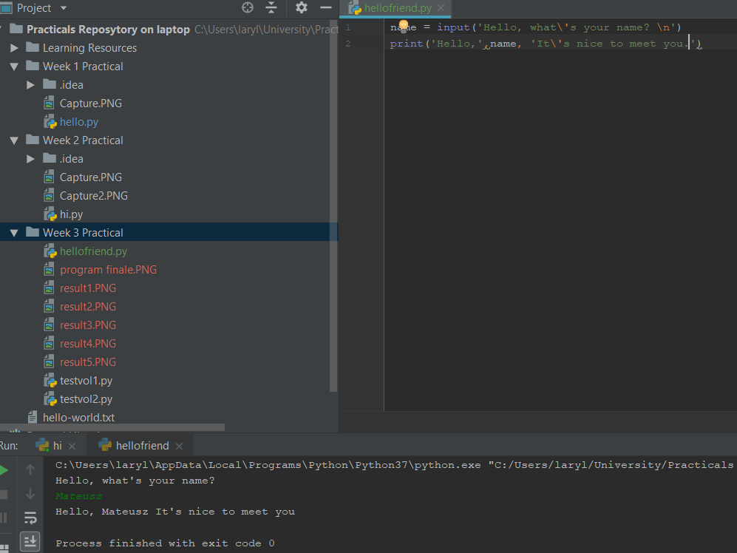

8. Amend the program from the previous activity so that if the name entered is blank the program simply outputs "Hello World", as before.

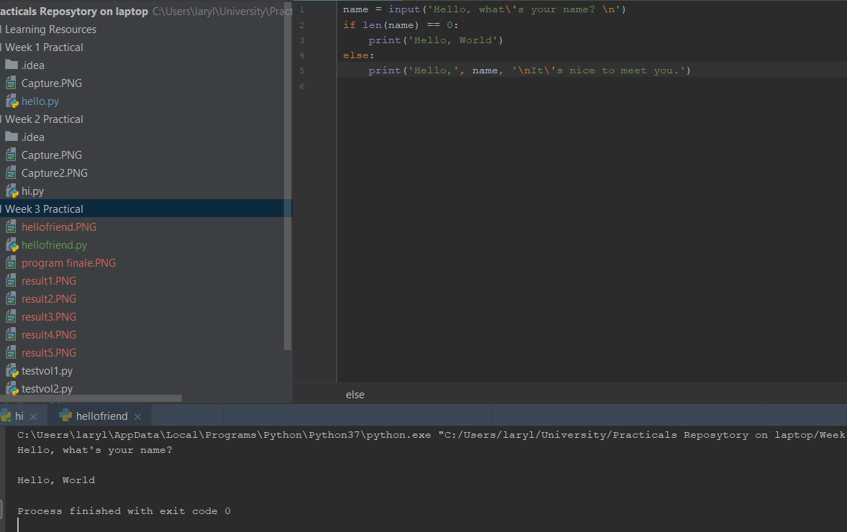

9. Write a program that prompts the user to enter four temperature readings. Once done, the program should display the highest, lowest and average reading. Note: This is not a challenge activity, but it is tricky. We have seen everything you need to do this in the lecture or in previous practicals.

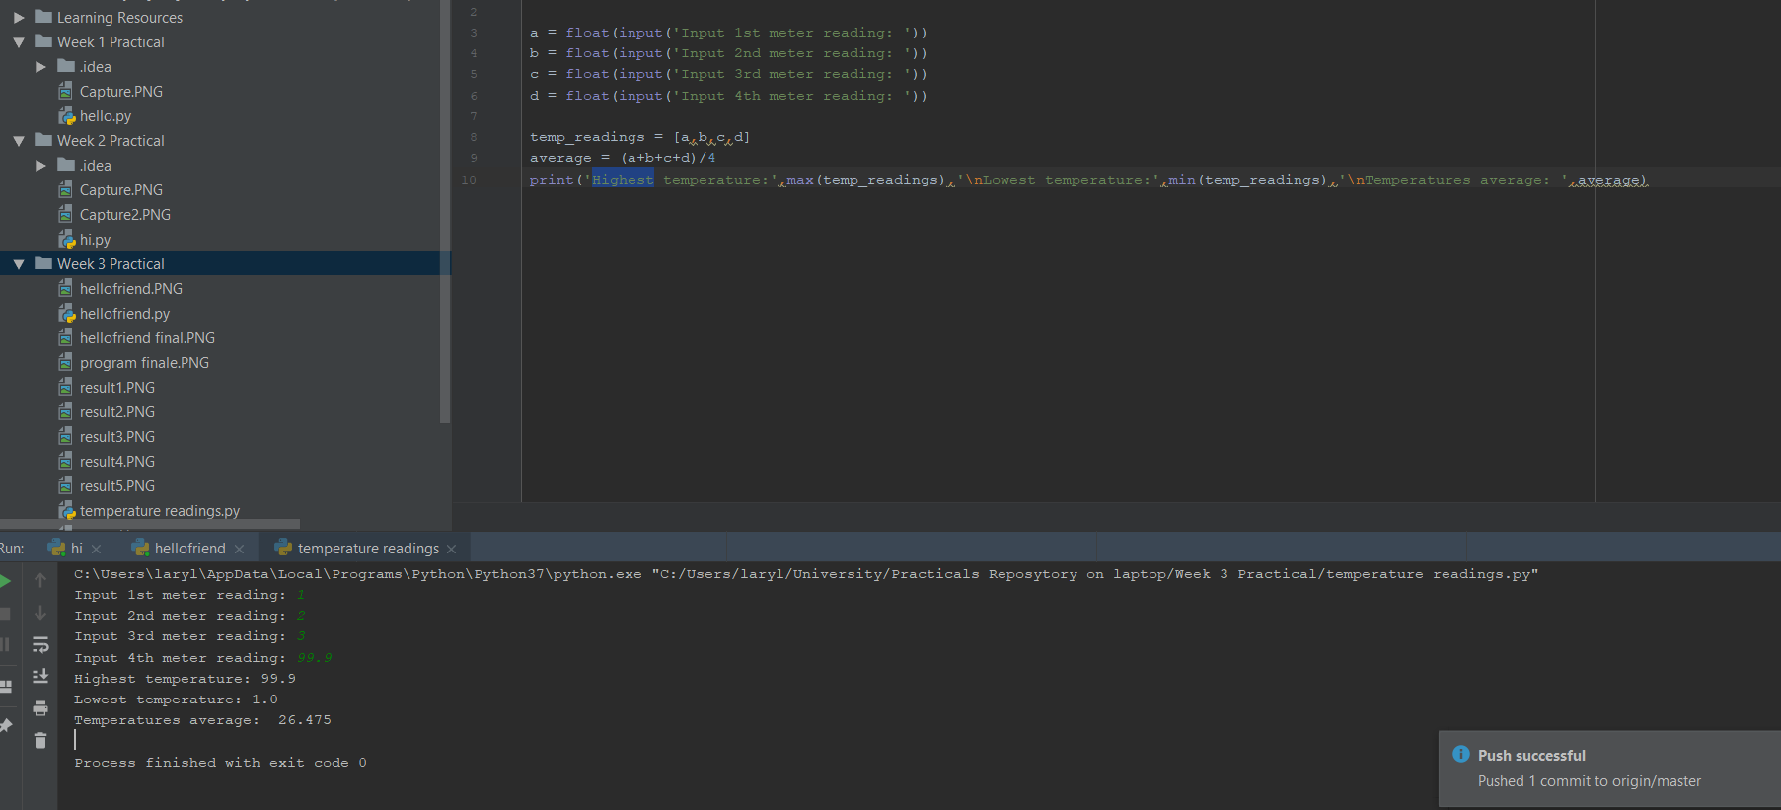

Practical week 4

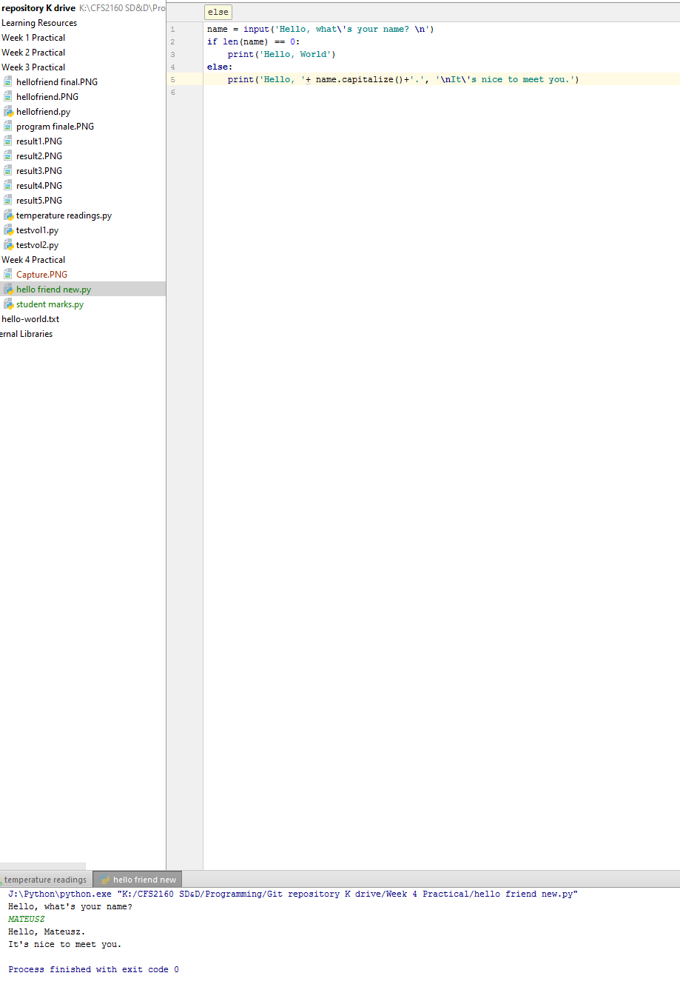
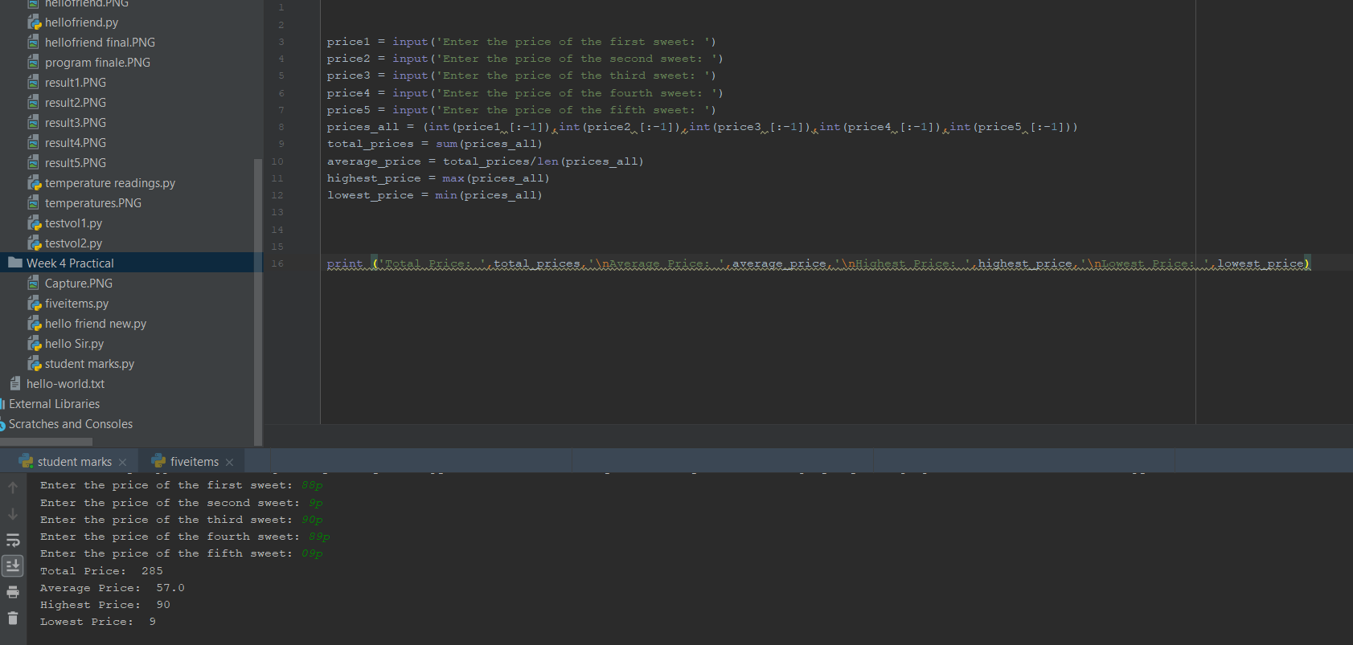

Week 8 (Lecture 7), java

3. java class Employee

Attributes:
- id (int)
- name (String)
- rating (int)

Methods:
- getId (returns Employee id , returns integer)
- setId ( sets Employee id , returns void)
- getName ( returns Employee name, returns String)
- setName (sets Employee name, returns void)
- getRating ( return Employee rating , returns integer)
- setRating ( sets Employee rating, returns void)

package week1;

public class Employee
{
private int id;
private String name;
private String jobTitle;
private String manager;
private int salary;

public Employee() {
}

public Employee(int id, String name) {
this.id = id;
this.name = name;
}

public Employee(int id, String name, String jobTitle, String manager, int salary) {
this.id = id;
this.name = name;
this.jobTitle = jobTitle;
this.manager = manager;
this.salary = salary;
}

public int getId () {
return id;
}

public void setId (int id) {
this.id = id;
}

public String getName () {
return name;
}

public void setName (String name) {
this.name = name;
}

public String getJobTitle () {
return jobTitle;
}

public void setJobTitle (String jobTitle) {
this.jobTitle = jobTitle;
}

public String getManager () {
return manager;
}

public void setManager (String manager) {
this.manager = manager;
}

public int getSalary () {
return salary;
}

public void setSalary (int salary) {
this.salary = salary;
}

public void giveSalaryRaise (int percentRaise) {
this.salary += (this.getSalary () * (percentRaise / 100.0));
}

public String parkingPermitStatus () {
if ((this.jobTitle.startsWith ("Senior")) && (this.getSalary () > 22000)) {
return "Employee is permitted a car parking space.";
}
else {
return "Employee is not permitted a car parking space.";
}
}

@Override
public String toString () {
final StringBuilder sb = new StringBuilder ("Employee{");

sb.append ("id=").append (id);
sb.append (", name='").append (name).append ('\'');
sb.append (", jobTitle='").append (jobTitle).append ('\'');
sb.append (", manager='").append (manager).append ('\'');
sb.append (", salary=").append (salary);
sb.append ('}');

return sb.toString ();
}

public static void main (String[] args) {

Employee jane = new Employee (123, "Jane Smith");
System.out.println("Creating an Employee ...\n" + jane);
jane.setSalary(24000);
System.out.println("\nSetting Salary ...\n" + jane);
jane.setManager("Barbara Forbes");
System.out.println("\nSetting Manager ...\n" + jane);
jane.giveSalaryRaise(5);
System.out.println("\nApplying 5% Salary Raise ...\n" + jane);
System.out.println("\nJane's Salary is " + jane.getSalary());
jane.setJobTitle("Senior Account Executive");
System.out.println("\nSetting Job Title ...\n" + jane);
System.out.println("\nFinding Car Parking Status ...\n" + jane.parkingPermitStatus());

}
}

